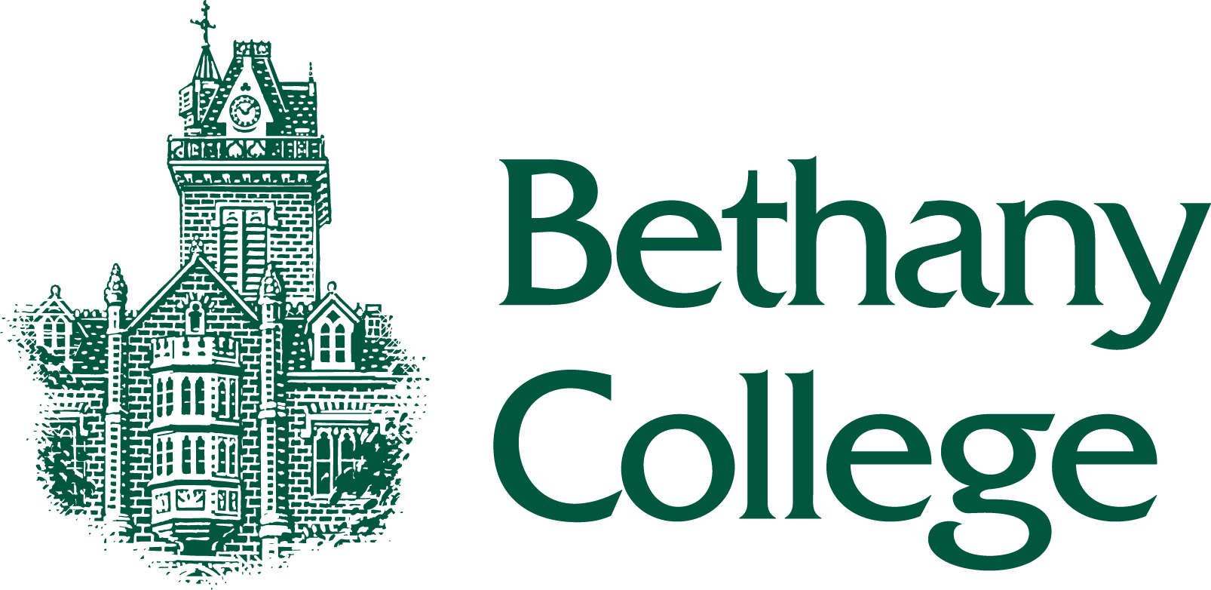
2024-2025
Student Work Study Program
AUTHORIZATION FORM
Student Section
Last Name: ______________________________
First Name: ______________________________
E Mail: __________________________________
Work Study Allotment $____________________
Student ID: ______________________________
Supervisor Section
Name of Department/Area___________________________
Supervisor Name___________________________________
Supervisor Phone # _________________________________
Supervisor E Mail___________________________________

Student Certification
I agree to accept employment in the department named above. I understand I am required to complete the 2024-25 FAFSA. I further understand I will be expected to perform my duties in a responsible manner, to comply with the requirements of the job, adhere to the instructions of my supervisor and follow the guidelines established by the Bethany College Student Employment Handbook. I understand my employment is contingent upon satisfactory job performance and being a student in good standing. I may be removed from my position and from the Student Work Study Program if I do not meet minimum standards. I will accurately record my work hours and will maintain a record of my earnings in order not to exceed my awarded financial aid limit. I will work a maximum of 1 work study position at 8 hours per week unless otherwise approved by the Financial Aid Office. I will stop working when I reach my awarded work-study allotment.
__________________________________ ________________________________
Student Signature Date

Supervisor Certification
I agree to hire the above-named student under the conditions described and adhere to the policies set by the Bethany College Student Employment Handbook. I will supervise the work performed and be responsible for approving the Student’s Time Sheet for the Student Payroll/Student Accounts Office. I will also be responsible for maintaining a record of student earnings and may not pay students beyond their earnings limit, which may be changed from the amount originally awarded by the Financial Aid Office. I will not allow the student to begin work until all paperwork is complete and approval received from the Financial Aid Office.
__________________________________________ ______________________________
Supervisor Signature Date
STUDENT IS NOT ELIGIBLE TO WORK UNTIL APPROVED BY FINANCIAL AID
______________________________________________ ____________________________
Jill Bittel Date
Associate VP of Financial Aid and Enrollment
A student is not cleared to begin any work-study position until a fully executed authorization form is returned to the employer or an email is sent stating the student is cleared. It is the student’s responsibility to return the authorization form to the Financial Aid Office. The student cannot be entered into a Web Time entry positions without clearance.

